SOP Number | Insert Number
SOP Title | Database Design (Using Excel)
 | NAME | TITLE | SIGNATURE | DATE
Author
Reviewer
Authoriser

Effective Date:

READ BY
NAME | TITLE | SIGNATURE | DATE

[This SOP template has been written as an example which can be adapted for use in any department conducting clinical research where there are no SOPs in place. The contents of the SOP should be reviewed in conjunction with the procedures which take place within the department and the text should be altered accordingly]

purpose
The purpose of this Standard Operating Procedure (SOP) is to describe the standard procedures to be followed when a recognised database for storage of clinical trial data is not in place. It sets out the procedure for storing clinical trial data in accordance with Good Clinical Practice guidelines.

introduction
ICH Guidelines for Good Clinical Practice (GCP) require that an electronic database should be fit for purpose; provide a clear audit trail; have security of access and be protected against deletions. The Data Protection Act 1998 requires data to be accurate and up to date, secure against loss, destruction, unlawful use or disclosure and to be processed fairly and lawfully. In a certain proportion of small-scale clinical trials, owing to their size and constraints on funding, there is little technical support for researchers in the design of databases. The aim of this document is to set out a method of optimising compliance with GCP when data are entered from Case Report Forms (CRF) into spreadsheets such as Microsoft Excel.

Scope
This SOP applies to clinical trials where the Oxford Radcliffe Hospitals NHS Trust has accepted the role of ‘Sponsor’ in the [INSERT NAME] department/ for the [INSERT NAME/NUMBER] trial.
This SOP applies to small-scale clinical trials, where there is no provision for software to enable design of a database in which to store clinical data. These trials will typically be trials where a small number of subjects are being recruited.
This SOP does not apply to commercially funded research or research sponsored by an external non-commercial organisations.

responsibilities

Chief Investigator or delegate
The Chief Investigator or delegate is responsible for the design and development of the database. The CI must ensure that all persons with access to the database have full understanding of its content and use. The CI must be satisfied that the electronic storage for the database is robust and secure. Computer access must be password protected
Note to author – password protection to an Excel spreadsheet may be enabled. However this should be used with caution since if the password is lost during or after the trial access to the database will be impossible, GCP and the Data Protection Act would be breached.

Data manager/data entry clerk/other
Define staff responsibilities for each staff role as appropriate to the study

procedure

Creation of data fields
A database should be designed using Microsoft Excel to ensure that it captures all the information that is required according to the protocol. It should directly reflect the content of the Case Report Form (CRF).

Worksheet identification
Create sufficient worksheets within the Excel file to cover each visit. Enter the name of the visit on the worksheet tabs.
Create additional worksheets to cover adverse event collection, concomitant medications etc. as applicable to the study.

Data field identification
Within each visit worksheet, and through reference to the CRF, enter a heading for each data entry as it appears on the CRF visit page. Each column should represent one data point.

Subject identification
Each row should represent one subject.
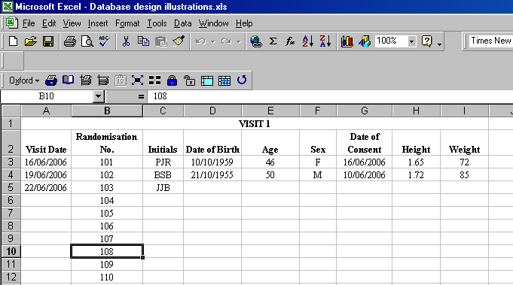

Optional advanced settings
To ensure that data added is accurate levels of validation can be added to the spreadsheet. Within certain fields, it is possible to restrict the type of data that can be added to a cell.
For example, if the column on the spreadsheet represents date of birth, selecting the date option form the validation criteria will only allow dates to be entered into that column. Furthermore, if the inclusion criteria of the study have a restriction on age range, a start and end date can be added. If the value is outside the settings, an error alert can be generated.
To set validation criteria, select the cells to be affected; choose Data, Validation and set your criteria under Input, Settings and Error Alert.

Example
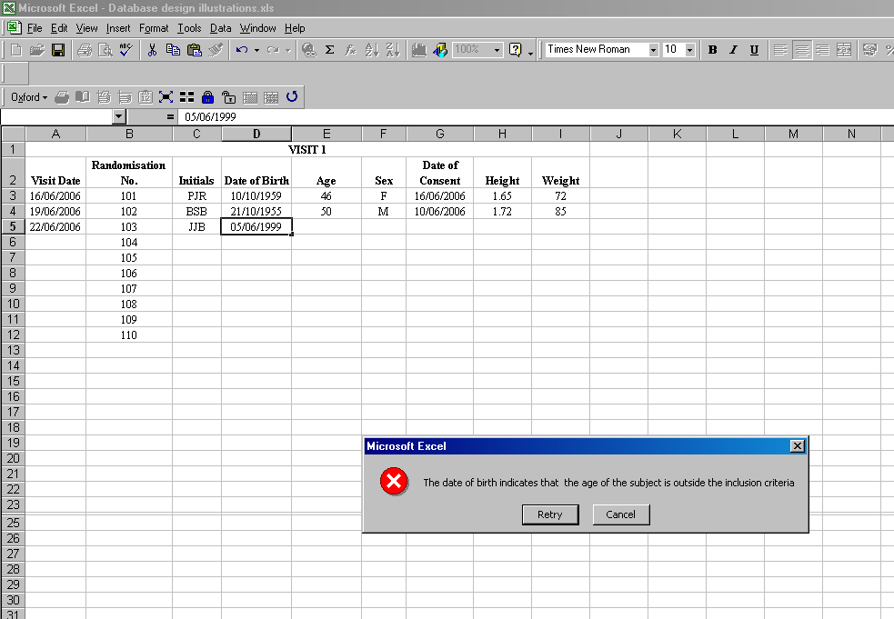

Validation of Spreadsheet
Once the spreadsheet design is considered to be complete, a validation process should be undertaken to ensure that it is ‘fit for purpose’, as below.

Create a sample CRF
Enter data for a hypothetical participant, ensuring that all data boxes are complete. Include data entry on Adverse Events and Concomitant Medications pages.

Transfer data to database.
Using the completed CRF, transfer all the data onto the database spreadsheet. Make a note of any difficulties involved in this process. Review each database page for errors or omissions.

Document validation
Once the spreadsheet is considered to be ‘fit for purpose’ the sample CRF and the printed spreadsheet should be filed as documentation of this process.

Creating and Using an Audit Trail
Note to author – although Excel includes a ‘Track changes’ facility with shared workbooks this is not sufficiently robust to meet GCP requirements. In particular tracking must be cancelled when certain changes need to be made to the worksheet.

Preparing ‘Read Only’ access.
Once development of the spreadsheet is complete, create a folder to store the worksheets. Right click on the folder. Select Properties. Select General tab. Tick ‘Read Only’ box and select ‘OK’.

Creating the trail
Once data entry commences, the file will require saving as a new file on every occasion it is accessed. To save files chronologically and record the identity of the member of the team adding to data, save with the date reversed, the time, and initials. This method will automatically file the workbooks in chronological order.
Example: 060624.1630.HH
060629.1115.HH
060629.1530.HH

Restricting Access
Access should be restricted to the minimum number of personnel. A folder should be established within which all the trial spreadsheet files should be stored. Your Information Technology department who should advise you how to restrict access as this depends on what type of access you require for which staff members.

Quality Checks
Unless you wish to undertake double data entry, it is important that periodic quality checks are conducted. You should form a plan for these prior to the study start and document this.
It is good practice to check at least 10% of Case Report Forms against entries on the database. This involves a simple comparison of the data for accuracy of transcription. Ideally, someone other than the person entering the data should undertake this. These quality checks should be documented and filed within the study file.

Confidentiality
The participants will be identified in the database only by initials and a participant ID number. The study will comply with the Data Protection Act which requires data to be anonymised as soon as it is practical to do so. Names and any other identifying detail will NOT be included in any study data electronic file.

forms/templates to be used
As applicable (screenshots of spreadsheets views may be added as an appendix)

Internal AND EXternal references
This section is used to list all controlled internal references (e.g. SOPs) and external references referred to within the text of the SOP only.

Internal References
Add as applicable

External References
ICH Harmonised Tripartite Guideline for Good Clinical Practice. http://www.ich.org
Data Protection Act 1998 http://www.ico.gov.uk/what_we_cover/data_protection.aspx
Directive 2001/20/EC of the European Parliament and of the Council of 4 April 2001 on the approximation of the laws, regulations and administrative provisions of the Member States relating to the implementation of good clinical practice in the conduct of medicinal products for human use.

Change History
Where the SOP is the initial version:
- SOP No: Record the SOP and version number
- Effective Date: Record effective date of the SOP or “see page 1”
- Significant Changes: State, “Initial version” or “new SOP”
- Previous SOP no.: State “NA”.
Where replacing a previous SOP:
- SOP No: Record the SOP and new version number
- Effective Date: Record effective date of the SOP or “see page 1”
- Significant Changes: Record the main changes from previous SOP
- Previous SOP no.: Record SOP and previous version number

SOP no. | Effective  Date | Significant Changes | Previous  SOP no.

